Sedimentary Rock Formation
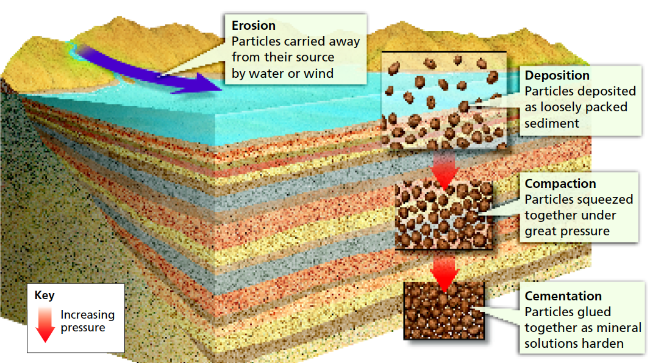
Erosion
Destructive forces are constantly breaking up and wearing away all the rocks on Earth’s surface. The forces include heat and cold, rain, waves, and grinding ice. Erosion occurs when running water or wind loosen and carry away the fragments of rock.

Deposition
Eventually, the moving water or wind slows and deposits the sediment. If water is carrying the sediment, rock fragments and other materials sink to the bottom of a lake or ocean. Deposition is the process by which sediment settles out of the water or wind carrying it. After sediment has been deposited, the processes of compaction and cementation change the sediment into sedimentary rock. In addition to particles of rock, sediment may include shells, bones, leaves, stems, and other remains of living things. Over time, any remains of living things in the sediment may slowly harden and change into fossils trapped in the rock.

Compaction
At first the sediments fit together loosely. But gradually, over millions of years, thick layers of sediment build up. These layers are heavy and press down on the layers beneath them. Then compaction occurs. Compaction is the process that presses sediments together. Year after year more sediment falls on top, creating new layers. The weight of the layers further compacts the sediments, squeezing them tightly together. The layers often remain visible in the sedimentary rock.

Cementation
While compaction is taking place, the minerals in the rock slowly dissolve in the water. The dissolved minerals seep into the spaces between particles of sediment. Cementation is the process in which dissolved minerals crystallize and glue particles of sediment together. It often takes millions of years for compaction and cementation to transform loose sediments into solid sedimentary rock.

