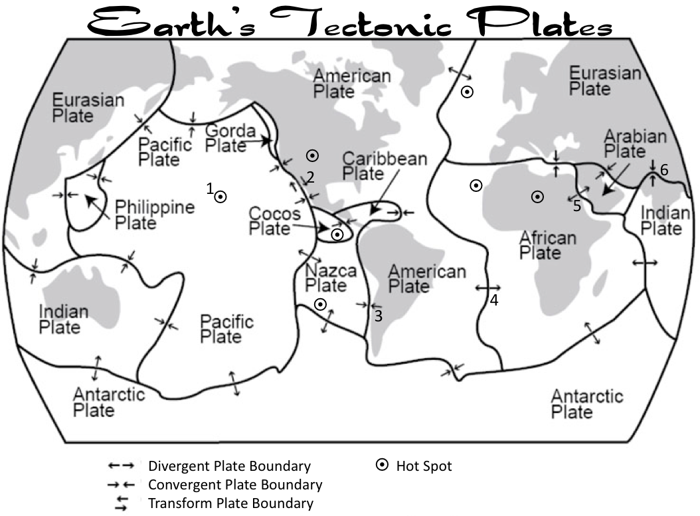

For each number on the map, state the type of plate boundary and what is happening to the plates at that number, use scientific vocabulary in your answer.

1. Hawaii:
2. California:
3. Chile:
4. Mid-Atlantic(ocean) Ridge:
5. Sudan:
6. Nepal:

