Type of Boundary | What does this type of  plate movement look like? | Plate Movement | What happens at this boundary?
Divergent |  | The place where two plates move apart, or diverge, is called a divergent boundary. | Most divergent boundaries occur at the Mid-Atlantic ridge. The Mid-Atlantic ridge is an underwater mountain range. It is the longest chain of mountains in the world. At the Mid-Atlantic ridge, molten material rises from the mantle and erupts. The molten material then spreads out, pushing older rock to both sides of the ridge. This process, called sea-floor spreading continually adds new material to the ocean floor.  When two continental plates pull apart, a deep valley called a rift valley forms.
Transform |  | A transform boundary is a place where two plates slip past each other, moving in opposite directions. | Earthquakes occur frequently along these boundaries.
Convergent |  | The place where two plates come together, or converge, is a convergent boundary. When two plates converge, the result is called a collision. | Subduction is the process of dense oceanic crust sliding under the less dense continental crust. Volcanoes occur along here.  When two plates carrying continental crust collide, subduction does not take place because both plates are made of the same low-density rock. Instead, the plates crash head-on. The collision squeezes the crust into mighty mountain ranges.
Hotspot (not a boundary) | A hot spot is a place where part of the mantle with a very high temperature rises through the crust causing volcanic eruptions. Hotspots do not occur at plate boundaries. Hot Spots record changes in plate motions because they are believed to be relatively stationary. These spots do not move and thus remain in fixed locations for tens of millions of years. The plates move over top of hot spots often creating chains of island volcanoes.  Hawaii, Iceland, and the Galapagos are present day examples of hot spots.
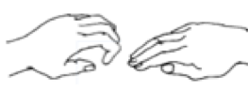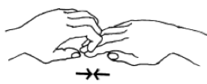

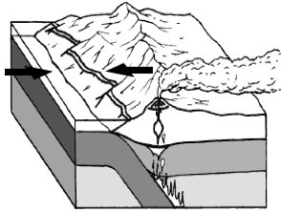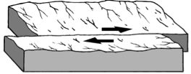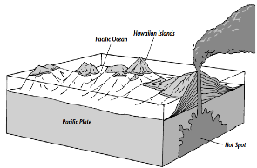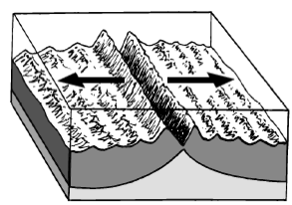Glue these pictures in the correct boxes

