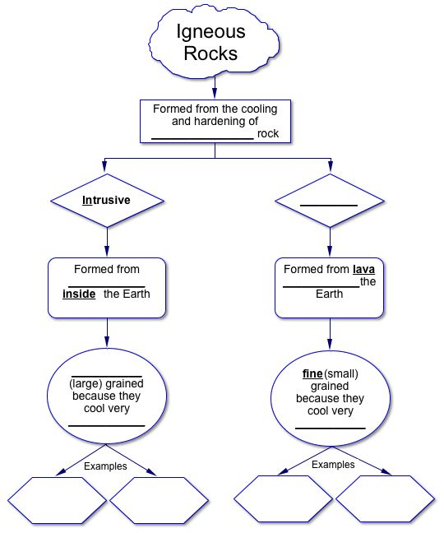
Igneous Rocks

Igneous rock is any rock that forms from magma or lava that cools and hardens in or near a volcano. The name “igneous” comes from the Latin word ignis, meaning “fire.” Igneous rocks are classified according to their origin, texture, and mineral composition.

Extrusive rock is igneous rock formed from lava that erupted onto Earth’s surface. Basalt is the most common extrusive rock. Igneous rock that formed when magma hardened beneath Earth’s surface is called intrusive rock. Granite is the most abundant intrusive rock in continental crust.

The texture of an igneous rock depends on the size and shape of its mineral crystals. The only exceptions to this rule are the different types of volcanic glass—igneous rock that lacks a crystal structure. Igneous rocks may be similar in mineral composition and yet have very different textures. Rapidly cooling lava forms fine-grained igneous rocks with small crystals. Slowly-cooling magma forms coarse-grained rock with large crystals. Intrusive rocks have larger crystals than extrusive rocks. Extrusive rocks have a fine-grained or glassy texture. Basalt, for example, is an extrusive rock whose crystals are too small to be seen without a microscope.

