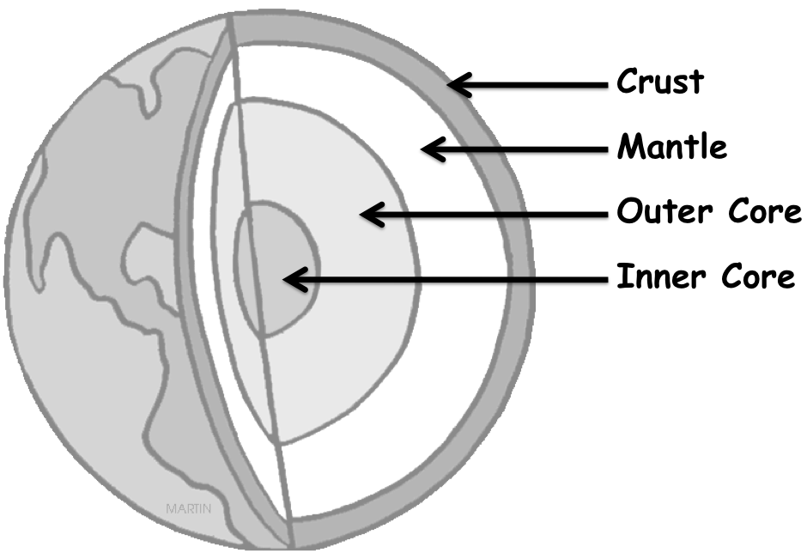
Scientists who study the Earths layers are called geologists. The Earth’s Interior is divided into three main layers; the core, the mantle, and the crust. The Earth is kind of like a big peach, the core would represent the pit, the mantle would be the flesh, and the crust would be the skin.

The Earth’s crust, where we live, is the solid outer-most layer of the Earth. There are two different types of crust: thin heavy oceanic crust that is under the oceans and thicker but lighter continental crust that is under the continents. These two different types of crust are made up of different types of rock. This is the coolest layer of earth. The crust is broken into different pieces called plates, which float on the mantle below. The movement in the mantle causes the pieces of the crust to move around and bump into each other. The thick of this layer varies from 5 km (under the oceans) to 70 km (under the highest elevations on land).

Earth's Mantle is the middle layer of the Earth. Many people think of this as lava, but it's actually rock. The mantle is solid and made of silicon, iron, magnesium, and oxygen. Even though it is a solid, it has some properties like a liquid. The rock is so hot, that it flows like road tar. This creates very slow-moving currents as hot rock rises from the depths and cooler rock descends. Because this layer is partially melted, it can be flexible (like silly putty) but moves much more slowly than liquid. The mantle extends down 2,900 km from the bottom of the crust. Temperature decreases in the mantle as you move away from the core. This causes the hot gooey mantle to rise towards the crust, where it cools and falls back to the core. This movement is an example of convection. The mantle contains about 68% of the Earths mass.

The Core is the inner most part of the Earth. Earth's core is composed mainly of iron and nickel metal. Scientists have assumed this based upon calculations of the core’s density and upon the fact that many meteorites (which are thought to be portions of the interior of a planet) are iron and nickel.

The core is divided into two different zones. The outer core is a liquid because the temperatures there are so high, it melts the metal. This layer is 2,200 km thick. However, the inner core is a solid even though its temperature is higher than the outer core. Here, tremendous pressure, produced by the weight of the overlying rocks is strong enough to crowd the atoms tightly together and prevents the liquid state. Because of the core’s hot temperatures, it is the Earth’s source of internal heat, which it radiates out to the next level, the mantle.

GENERAL CHARACTERISTICS OF THE LAYERS OF THE EARTH

 | What makes up this layer? | Average Thickness (km) | Temperature (Celsius) | Average Pressure (atm) | % of Earths mass | % of Earths volume
Crust | oxygen, magnesium aluminum, silicon calcium, sodium potassium, iron | 35 (continents)  7 (oceans) | 0 - 870 | 1 | 2.2% | 4.3%
Mantle | silicon, oxygen aluminum, iron | 2900 | 870 – 3,700 | 1,400,000 | 68.4% | 79.8%
Outer Core | iron, nickel (liquid) | 2200 | 3,700 – 4,300 | 2,000,000 | 27.5% | 15%
Inner Core | iron, nickel (solid) | 1270 | 4,300 – 7,200 | 3,500,000 | 1.9% | 0.9%

- The element that is part of every layer of the Earth is: __________________________________.

- The _______________________________________ is the thickest layer of the Earth.

- The _________________________________________ layer weighs the most.

- The word overlying in paragraph 5 means: ___________________________________________.

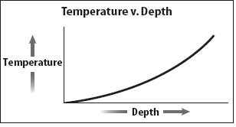
- Based on the graph to the right, describe what happens to temperature as you go towards the inner core of Earth.

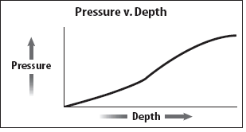
- Based on the graph to the right, describe what happens to pressure as you go towards the inner core of Earth.

