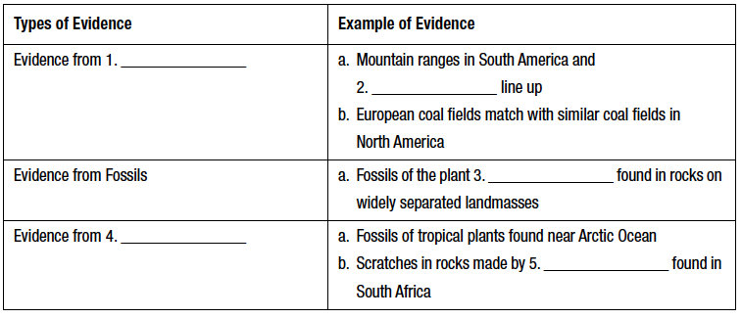
Drifting Continents

- What title did you choose for the reading? Why did you choose this title? Support your answer with
evidence from the text.
____________________________________________________________________________________

____________________________________________________________________________________

____________________________________________________________________________________

____________________________________________________________________________________

____________________________________________________________________________________

____________________________________________________________________________________

- What was Alfred Wegener’s hypothesis? ___________________________________________________

____________________________________________________________________________________

____________________________________________________________________________________

- Wegener named his supercontinent ________________________________ meaning “all lands”.

- What did Wegener think had happened to this supercontinent?

____________________________________________________________________________________

____________________________________________________________________________________

- Wegener’s idea that the continents slowly moved over Earth’s surface became known as

________________________________ ___________________________.

