Use your notebook and the texts at each station’s table to answer the questions below.

Amazing Ice Melting Blocks

- Which block do you think will melt the ice the quickest, Block A or Block B?

____/2

- Why does block A feel colder than block B? Explain
____/3

- Was your answer to #1 right or wrong? Which block actually melted the ice the quickest? Explain why this happened. Use science vocabulary!
____/4

The Lavish Lava Lamp

- What type of heat transfer is being shown in the lava lamp?
____/2

- What causes the ‘lava’ to rise in the lava lamp? Explain.
____/3

- What causes the ‘lava’ to fall back down in the lava lamp? Explain.
____/3

Koche’s Tanning Salon

- What is the heat source in Koche’s habitat?
____/2

- How does the heat reach Koche? Use scientific vocabulary and explain the type of heat transfer used.
____/3

- Koche would like you to design a shirt for him to wear that would help him absorb more heat. How would you design his shirt?
____/3

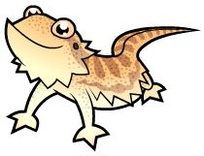

Go back and check to see if you wrote in complete sentences. Also make sure that you explained
all of your answers using information from the texts!

